**Assignment 2**

Name: Pallavi Dadape

Roll No.: 43239

College ID:



Problem Statement:

Apply CSS properties border, margins, padding, navigation, dropdown list to the page created in the first assignment.

**CODES**

**index.css**

<!DOCTYPE html>

<html>

<head>

<title>One More Chapter | Your personalized online bookshelf</title>

<style>

* {

box-sizing: border-box;

}

body

{

font-family: Arial;

padding: 10px;

background: #f1f1f1;

background-color:lightcyan ;

}

/* Header Title */

.header

{

padding: 30px;

text-align: center;

background: white;

}

.header h1

{

font-size: 50px;

}

/* Style the top navigation bar */

.topnav

{

overflow: hidden;

background-color: #333; /* dark charcoal */

}

/* Style the topnav links */

.topnav a

{

float: left;

display: block;

color: #FFFFFF; /* white color logo area */

text-align: center;

padding: 14px 16px;

text-decoration: none;

}

/* Change color on hover */

.topnav a:hover

{

background-color: #ddd;

color: black;

}

/* Create two unequal columns that floats next to each other */

/* Left column */

.leftcolumn

{

float: left;

width: 75%;

}

/* Right column */

.rightcolumn

{

float: left;

width: 25%;

background-color: #FFFFFF;

padding-left: 20px;

}

/* Fake image */

.fakeimg

{

background-color: #FFFFFF;

text-align: center;

/*width: 100%;*/

padding: 20px;

}

/* Add a card effect for articles */

.card

{

background-color: white;

padding: 20px;

margin-top: 20px;

}

/* Clear floats after the columns */

.row:after

{

content: "";

display: table;

clear: both;

}

/* Footer */

.footer

{

padding: 20px;

text-align: center;

background: #ddd;

margin-top: 20px;

}

/* Responsive layout - when the screen is less than 800px wide, make the two columns stack on top of each other instead of next to each other */

@media screen and (max-width: 800px)

{

.leftcolumn, .rightcolumn

{

width: 100%;

padding: 0;

}

}

/* Responsive layout - when the screen is less than 400px wide, make the navigation links stack on top of each other instead of next to each other */

@media screen and (max-width: 400px)

{

.topnav a

{

float: none;

width: 100%;

}

}

</style>

</head>

<body>

<div class="header">

<h1> ONE MORE CHAPTER </h1>

<h2> Your personalized online bookshelf </h2>

</div>

<div class="topnav">

<a href="index_css.html">Home</a>

<a href="books_css.html">Books</a>

</div>

<div class="row">

<div class="leftcolumn">

<div class="card">

<h2> BOOKS </h2>

<h5>Explore various genres that our shelves carry in the collection. </h5>

<div class="fakeimg" >

<!-- <a href="books_css.html"> -->

<img src="logo.jpg" alt="Logo" style="height:500px; width:500px">

</a>

</div>

<p> Greetings folks! </p>

<p> There are two types of people in the world. One who like reading book and the other who don't. I belong to the second category who doesn't like reading books. But this website is for the first type of people who like reading books. </p>

<p> Many a time what happens is that when we go out to buy a book from the stores, we don't realize that we already have books in our shelves at our homes and that there is no space to keep the new ones you are buying. Hence I thought of this idea - an online bookstore. You can have your own bookshelf with all the books you wish to read from our collection. </p>

<br >

</div>

<div class="footer">

<p> <b> Contact information: </b> <a href="mailto:pal.dadpe@gmail.com">Pallavi Dadape</a>.</p>

<p> <b> Posted by: </b> Pallavi Dadape</p>

<p> <b> Posted by: </b> 7402629803</p>

</div>

</body>

</html>

**books.css**

<!DOCTYPE html>

<html>

<head>

<title>One More Chapter | Your personalized online bookshelf</title>

<style>

* {

box-sizing: border-box;

}

body {

font-family: Arial;

padding: 10px;

background: #FFFFFF;

background-color:mintcream ;

}

/* Header/Blog Title */

.header {

padding: 30px;

text-align: center;

background: white;

}

.header h1 {

font-size: 50px;

}

/* Style the top navigation bar */

.topnav {

overflow: hidden;

background-color: #333;

}

/* Style the topnav links */

.topnav a {

float: left;

display: block;

color: #f2f2f2;

text-align: center;

padding: 14px 16px;

text-decoration: none;

}

/* Change color on hover */

.topnav a:hover {

background-color: #ddd;

color: black;

}

/* Create two unequal columns that floats next to each other */

/* Left column */

.leftcolumn {

float: left;

width: 75%;

}

/* Right column */

.rightcolumn {

float: left;

width: 25%;

background-color: #FFFFFF;

padding-left: 20px;

}

/* Fake image */

.fakeimg {

background-color: #FFFFFF;

/*width: 100%;*/

padding: 20px;

}

/* Add a card effect for articles */

.card {

background-color: white;

padding: 20px;

margin-top: 20px;

}

/* Clear floats after the columns */

.row:after {

content: "";

display: table;

clear: both;

}

/* Footer */

.footer {

padding: 20px;

text-align: center;

background: #ddd;

margin-top: 20px;

}

/* Responsive layout - when the screen is less than 800px wide, make the two columns stack on top of each other instead of next to each other */

@media screen and (max-width: 800px) {

.leftcolumn, .rightcolumn {

width: 100%;

padding: 0;

}

}

/* Responsive layout - when the screen is less than 400px wide, make the navigation links stack on top of each other instead of next to each other */

@media screen and (max-width: 400px)

{

.topnav a {

float: none;

width: 100%;

}

}

</style>

</head>

<body>

<div class="header">

<h1>ONE MORE CHAPTER</h1>

</div>

<div class="topnav">

<a href="index_css.html">Home</a>

<a href="book_css.html">Books</a>

</div>

<div class="row">

<div class="leftcolumn">

<div class="card">

<h2>BOOKS</h2>

<h4>Explore various genre in our bookstore</h4>

<div class="fakeimg" ><a href="crime_css.html"> <!--a href= "Crime_css.html"-->

<img src="Crime.jpeg" alt="CRIME" style="height:300px; width:900px">

</a>

</div>

<p> <b> Crime </b> </p>

<p>From Agatha Christie to David Baldacci, we offers many books. </p>

</div>

<div class="fakeimg" ><a href="fiction_css.html"> <!--a href= "Fiction_css.html"-->

<img src="Fiction.jpg" alt="FICTION" style="height:300px; width:900px">

</a>

</div>

<p> <b> Fiction </b> </p>

<p> We offer books from J. K. Rowling to Margaret Atwood and many more.</p>

</div>

<div class="rightcolumn">

<div class="card">

<h2>About Me</h2>

<div class="fakeimg" style="height:200px;">

<a href="index_css.html"> <img src="logo.jpg" alt="StoreFront" width="230" height="160" ></div> </a>

<p>Some text about me ..</p>

</div>

<div class="card">

<h3>Popular Books</h3>

<div class="fakeimg" style="height:200px;"> <a href ="https://www.pdfdrive.com/who-moved-my-cheese-an-amazing-way-to-deal-with-change-in-your-work-and-in-your-life-e159027317.html" > <img src="book1.jpg" alt="Book 1" width="150" height="200"></div> </a>

<br>

<div class="fakeimg" style="height:200px;"> <a href = "https://www.pdfdrive.com/rich-dad-poor-dad-for-teens-the-secrets-about-money-that-you-dont-learn-in-school-e156720180.html" > <img src="book2.jpg" alt="Book 2" width="150" height="200"></div> </a>

<br>

<div class="fakeimg" style="height:200px;"> <a href = "https://www.pdfdrive.com/the-power-of-positive-thinking-e195068504.html" > <img src="book3.png" alt="Book 3" width="150" height="200"></div> </a>

<br>

</div>

<!--

<div class="card">

<h3>Follow Me</h3>

<p>Some text..</p>

</div>

-->

</div>

</div>

<div class="footer">

<p> <b> Contact information: </b> <a href="mailto:pal.dadpe@gmail.com">Pallavi Dadape</a> </p>

<p> <b> Posted by: </b> Pallavi Dadape</p>

<p> <b> Posted by: </b> 7402629803</p>

</div>

</body>

</html>

**fiction.css**

<!DOCTYPE html>

<html>

<head>

<title>One More Chapter | Your personalized online bookshelf</title>

<style>

* {

box-sizing: border-box;

}

body {

font-family: Arial;

padding: 10px;

background: #f1f1f1;

background-color:mintcream ;

}

/* Header/Blog Title */

.header {

padding: 30px;

text-align: center;

background: white;

}

.header h1 {

font-size: 50px;

}

/* Style the top navigation bar */

.topnav {

overflow: hidden;

background-color: #333;

}

/* Style the topnav links */

.topnav a {

float: left;

display: block;

color: #f2f2f2;

text-align: center;

padding: 14px 16px;

text-decoration: none;

}

/* Change color on hover */

.topnav a:hover {

background-color: #ddd;

color: black;

}

/* Create two unequal columns that floats next to each other */

/* Left column */

.leftcolumn {

float: left;

width: 75%;

}

/* Right column */

.rightcolumn {

float: left;

width: 25%;

background-color: #FFFFFF;

padding-left: 20px;

}

/* Fake image */

.fakeimg {

background-color: #FFFFFF;

/*width: 100%;*/

padding: 20px;

}

/* Add a card effect for articles */

.card {

background-color: white;

padding: 20px;

margin-top: 20px;

}

/* Clear floats after the columns */

.row:after {

content: "";

display: table;

clear: both;

}

/* Footer */

.footer {

padding: 20px;

text-align: center;

background: #ddd;

margin-top: 20px;

}

/* Responsive layout - when the screen is less than 800px wide, make the two columns stack on top of each other instead of next to each other */

@media screen and (max-width: 800px) {

.leftcolumn, .rightcolumn {

width: 100%;

padding: 0;

}

}

/* Responsive layout - when the screen is less than 400px wide, make the navigation links stack on top of each other instead of next to each other */

@media screen and (max-width: 400px)

{

.topnav a {

float: none;

width: 100%;

}

}

</style>

</head>

<body>

<div class="header">

<h1>ONE MORE CHAPTER</h1>

</div>

<div class="topnav">

<a href="index_css.html">Home</a>

<a href="books_css.html">Books</a>

</div>

<div class="row">

<div class="leftcolumn">

<div class="card">

<h2>FICTION GENRE</h2>

<h5>Explore various authors belonging to this genre. </h5>

<div class="fakeimg" >

<a href="https://www.pdfdrive.com/harry-potter-and-the-cursed-child-parts-one-and-two-e184096963.html">

<img src="fiction1.jpg" alt="Harry Potter & the Cursed Child" style="height:400px; width:200px"> <!-- Book name-->

</a>

<br >

Title: Harry Potter & the Cursed Child

<br >

Author: J. K. Rowling </div>

</div>

<div class="fakeimg" >

<a href="https://www.pdfdrive.com/the-handmaids-tale-e195121445.html">

<img src="fiction2.jpg" alt="The Handmaid's Tale" style="height:400px; width:200px"> <!-- Book name-->

</a>

<br >

Title: The Handmaid's Tale

<br >

Author: Margaret Atwood </div>

</div>

<div class="rightcolumn">

<div class="card">

<h2>About Me</h2>

<div class="fakeimg" style="height:200px;">

<a href="index_css.html"> <img src="logo.jpg" alt="StoreFront" width="230" height="160" ></div> </a>

</div>

<div class="card">

<h3>Popular Books</h3>

<div class="fakeimg" style="height:200px;"> <a href ="https://www.pdfdrive.com/partners-in-crime-a-tommy-tuppence-adventure-e194142334.html" > <img src="cbook1.jpg" alt="Book 1" width="150" height="200"></div> </a>

<br>

<div class="fakeimg" style="height:200px;"> <a href = "https://www.pdfdrive.com/the-hound-of-the-baskervilles-e32573870.html" > <img src="cbook2.jpg" alt="Book 2" width="150" height="200"></div> </a>

<br>

<div class="fakeimg" style="height:200px;"> <a href = "https://www.pdfdrive.com/the-davinci-code-e197754922.html" > <img src="cbook3.jpg" alt="Book 3" width="150" height="200"></div> </a>

</div>

<!--

<div class="card">

<h3>Follow Me</h3>

<p>Some text..</p>

</div>

-->

</div>

</div>

<div class="footer">

<p> <b> Contact information: </b> <a href="mailto:pal.dadpe@gmail.com">Pallavi Dadape</a>.</p>

<p> <b> Posted by: </b> Pallavi Dadape</p>

<p> <b> Posted by: </b> 7402629803</p>

</div>

</body>

</html>

**crime.css**  
<!DOCTYPE html>

<html>

<head>

<title>One More Chapter | Your personalized online bookshelf</title>

<style>

* {

box-sizing: border-box;

}

body {

font-family: Arial;

padding: 10px;

background: #f1f1f1;

background-color:mintcream ;

}

/* Header/Blog Title */

.header {

padding: 30px;

text-align: center;

background: white;

}

.header h1 {

font-size: 50px;

}

/* Style the top navigation bar */

.topnav {

overflow: hidden;

background-color: #333;

}

/* Style the topnav links */

.topnav a {

float: left;

display: block;

color: #f2f2f2;

text-align: center;

padding: 14px 16px;

text-decoration: none;

}

/* Change color on hover */

.topnav a:hover {

background-color: #ddd;

color: black;

}

/* Create two unequal columns that floats next to each other */

/* Left column */

.leftcolumn {

float: left;

width: 75%;

}

/* Right column */

.rightcolumn {

float: left;

width: 25%;

background-color: #FFFFFF;

padding-left: 20px;

}

/* Fake image */

.fakeimg {

background-color: #FFFFFF;

/*width: 100%;*/

padding: 20px;

}

/* Add a card effect for articles */

.card {

background-color: white;

padding: 20px;

margin-top: 20px;

}

/* Clear floats after the columns */

.row:after {

content: "";

display: table;

clear: both;

}

/* Footer */

.footer {

padding: 20px;

text-align: center;

background: #ddd;

margin-top: 20px;

}

/* Responsive layout - when the screen is less than 800px wide, make the two columns stack on top of each other instead of next to each other */

@media screen and (max-width: 800px) {

.leftcolumn, .rightcolumn {

width: 100%;

padding: 0;

}

}

/* Responsive layout - when the screen is less than 400px wide, make the navigation links stack on top of each other instead of next to each other */

@media screen and (max-width: 400px)

{

.topnav a {

float: none;

width: 100%;

}

}

</style>

</head>

<body>

<div class="header">

<h1>ONE MORE CHAPTER</h1>

</div>

<div class="topnav">

<a href="index_css.html">Home</a>

<a href="books_css.html">Books</a>

</div>

<div class="row">

<div class="leftcolumn">

<div class="card">

<h2>CRIME GENRE</h2>

<h5>Explore various authors belonging to this genre. </h5>

<div class="fakeimg" >

<a href="https://www.pdfdrive.com/search?q=in+cold+blood&pagecount=&pubyear=&searchin=&em=">

<img src="crime1.jpg" alt="In Cold Blood" style="height:400px; width:200px"> <!-- Book name-->

</a>

<br >

Title: In Cold Blood

<br >

Author: Truman Capote </div>

</div>

<div class="fakeimg" >

<a href="https://www.pdfdrive.com/memory-man-e194963700.html">

<img src="crime2.jpg" alt="Memory Man" style="height:400px; width:200px"> <!-- Book name-->

</a>

<br >

Title: Memory Man

<br >

Author: David Baldacci </div>

</div>

<div class="rightcolumn">

<div class="card">

<h2>About Me</h2>

<div class="fakeimg" style="height:200px;">

<a href="index_css.html"> <img src="logo.jpg" alt="StoreFront" width="230" height="160" ></div> </a>

</div>

<div class="card">

<h3>Popular Books</h3>

<div class="fakeimg" style="height:200px;"> <a href ="https://www.pdfdrive.com/partners-in-crime-a-tommy-tuppence-adventure-e194142334.html" > <img src="cbook1.jpg" alt="Book 1" width="150" height="200"></div> </a>

<br>

<div class="fakeimg" style="height:200px;"> <a href = "https://www.pdfdrive.com/the-hound-of-the-baskervilles-e32573870.html" > <img src="cbook2.jpg" alt="Book 2" width="150" height="200"></div> </a>

<br>

<div class="fakeimg" style="height:200px;"> <a href = "https://www.pdfdrive.com/the-davinci-code-e197754922.html" > <img src="cbook3.jpg" alt="Book 3" width="150" height="200"></div> </a>

</div>

<!--

<div class="card">

<h3>Follow Me</h3>

<p>Some text..</p>

</div>

-->

</div>

</div>

<div class="footer">

<p> <b> Contact information: </b> <a href="mailto:pal.dadpe@gmail.com">Pallavi Dadape</a>.</p>

<p> <b> Posted by: </b> Pallavi Dadape</p>

<p> <b> Posted by: </b> 7402629803</p>

</div>

</body>

</html>

**SCREENSHOTS**

Screen 1 - 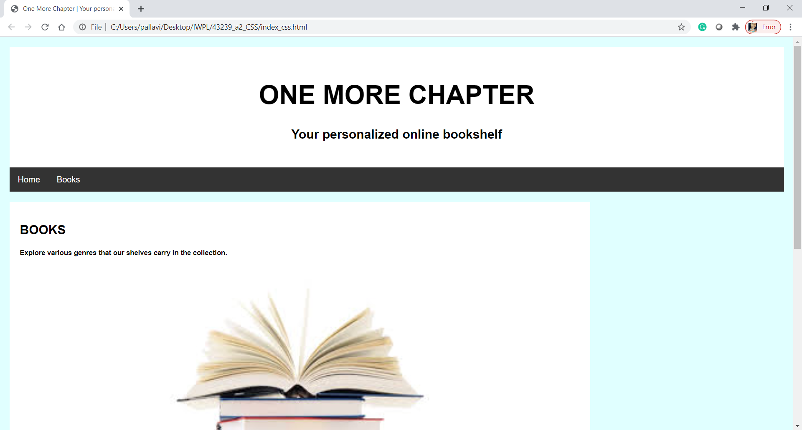

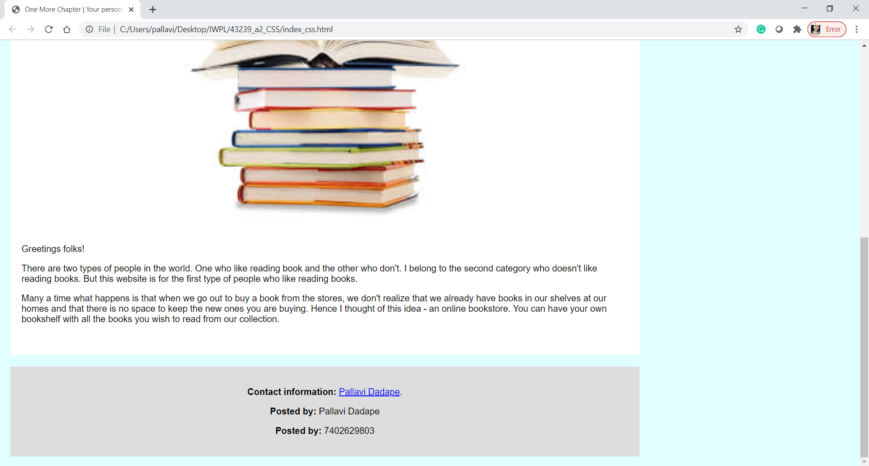

Screen 2 -

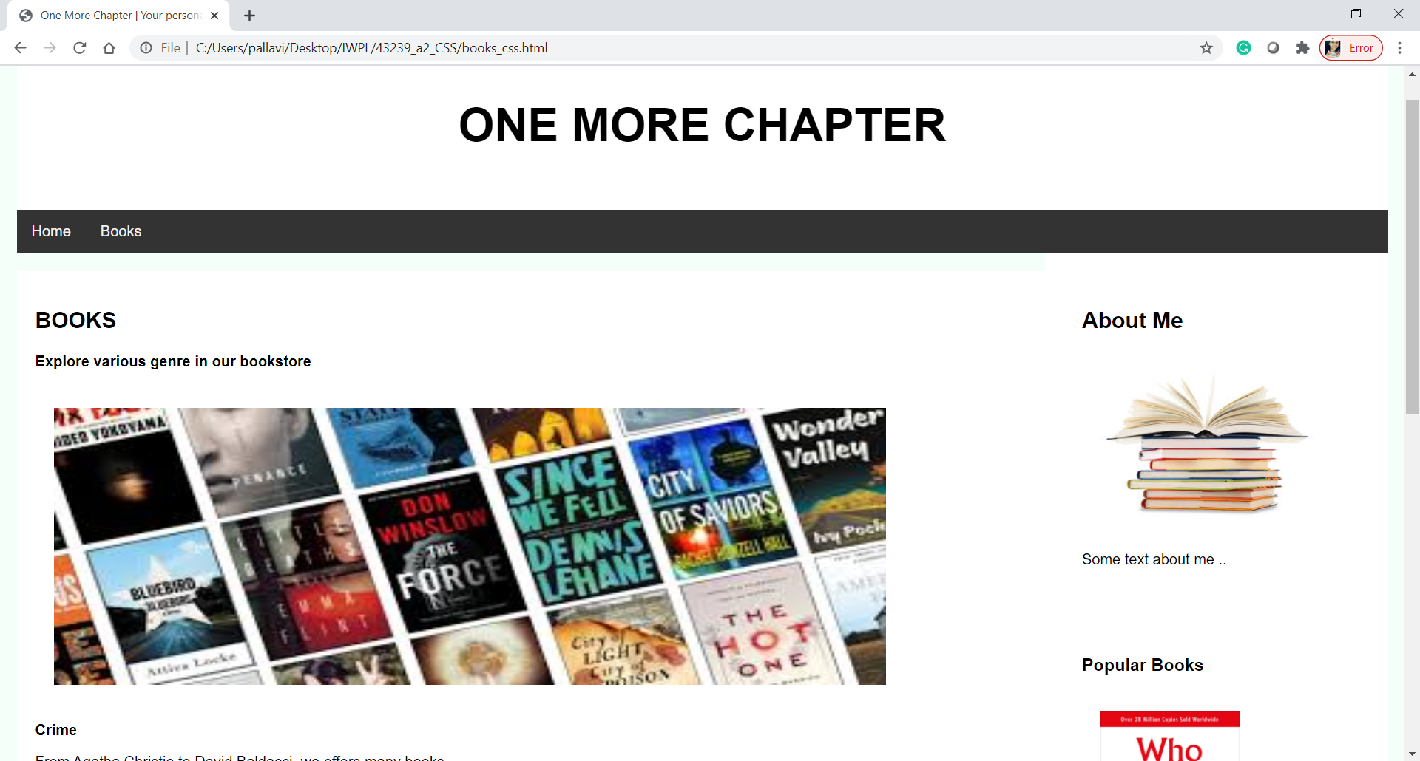

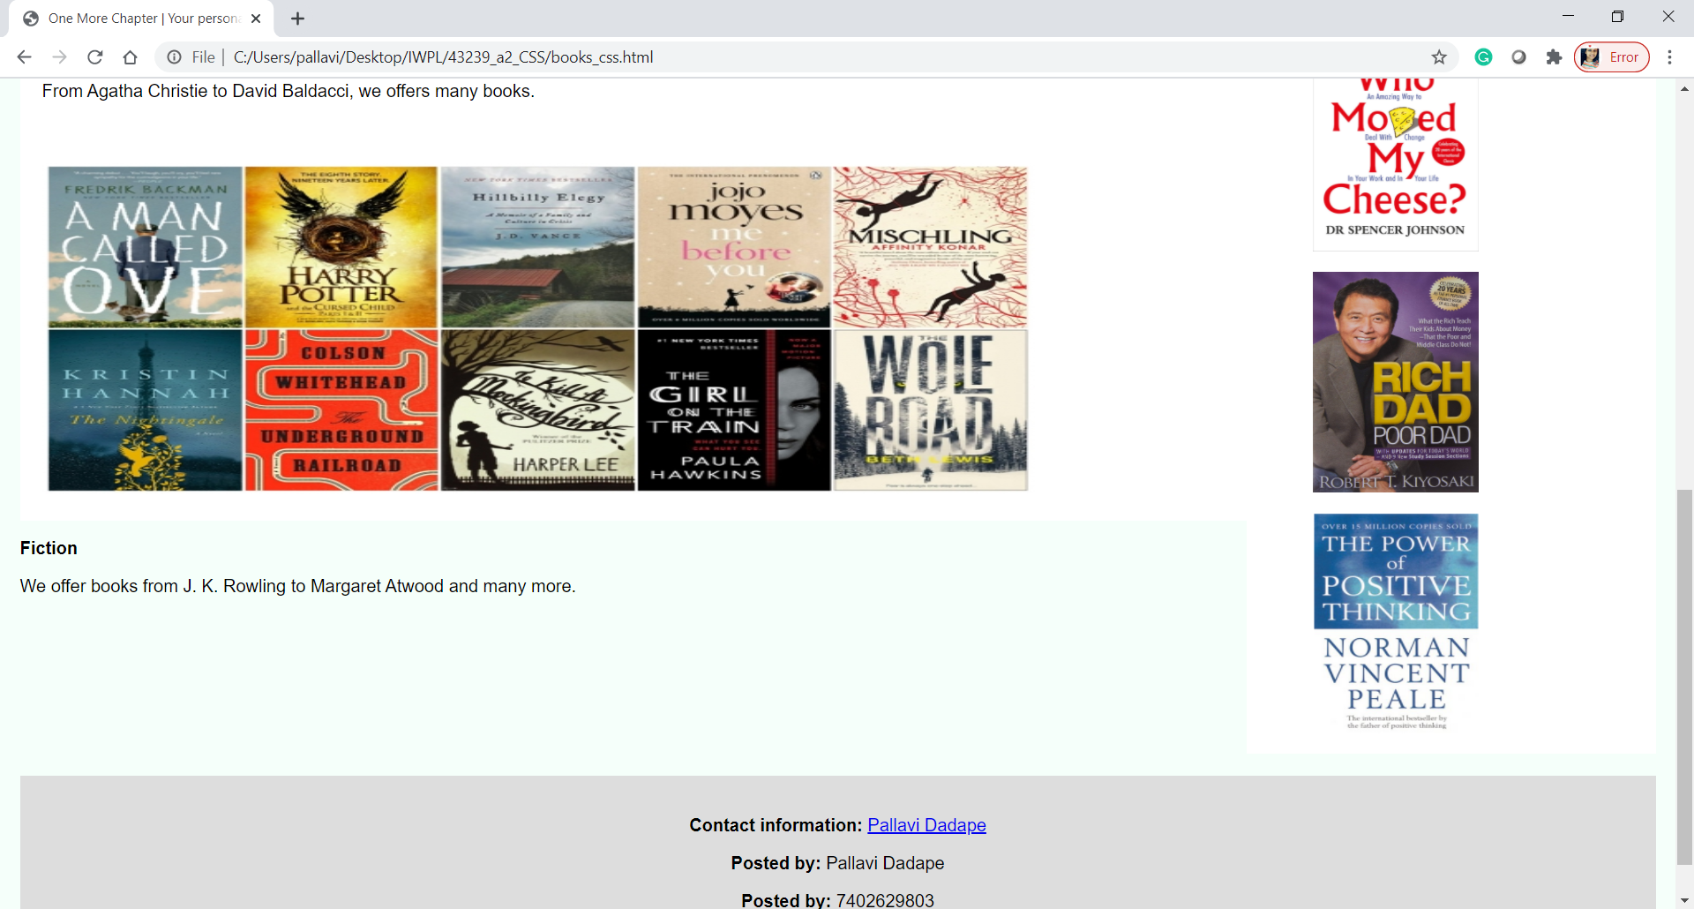

Screen 3.1 -

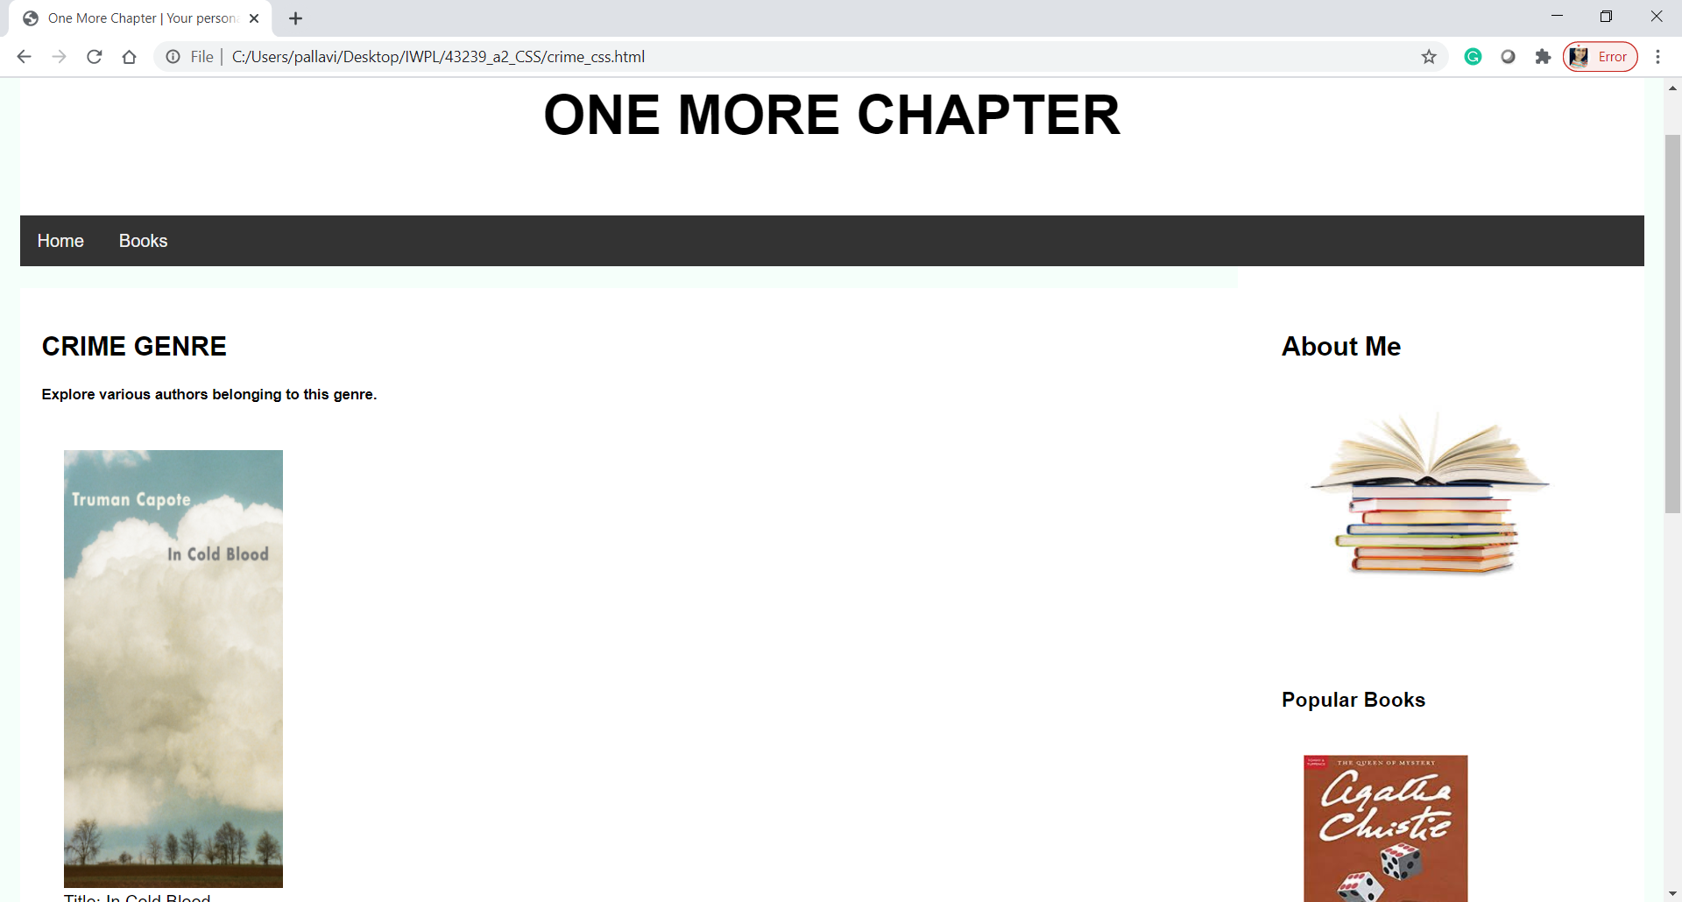

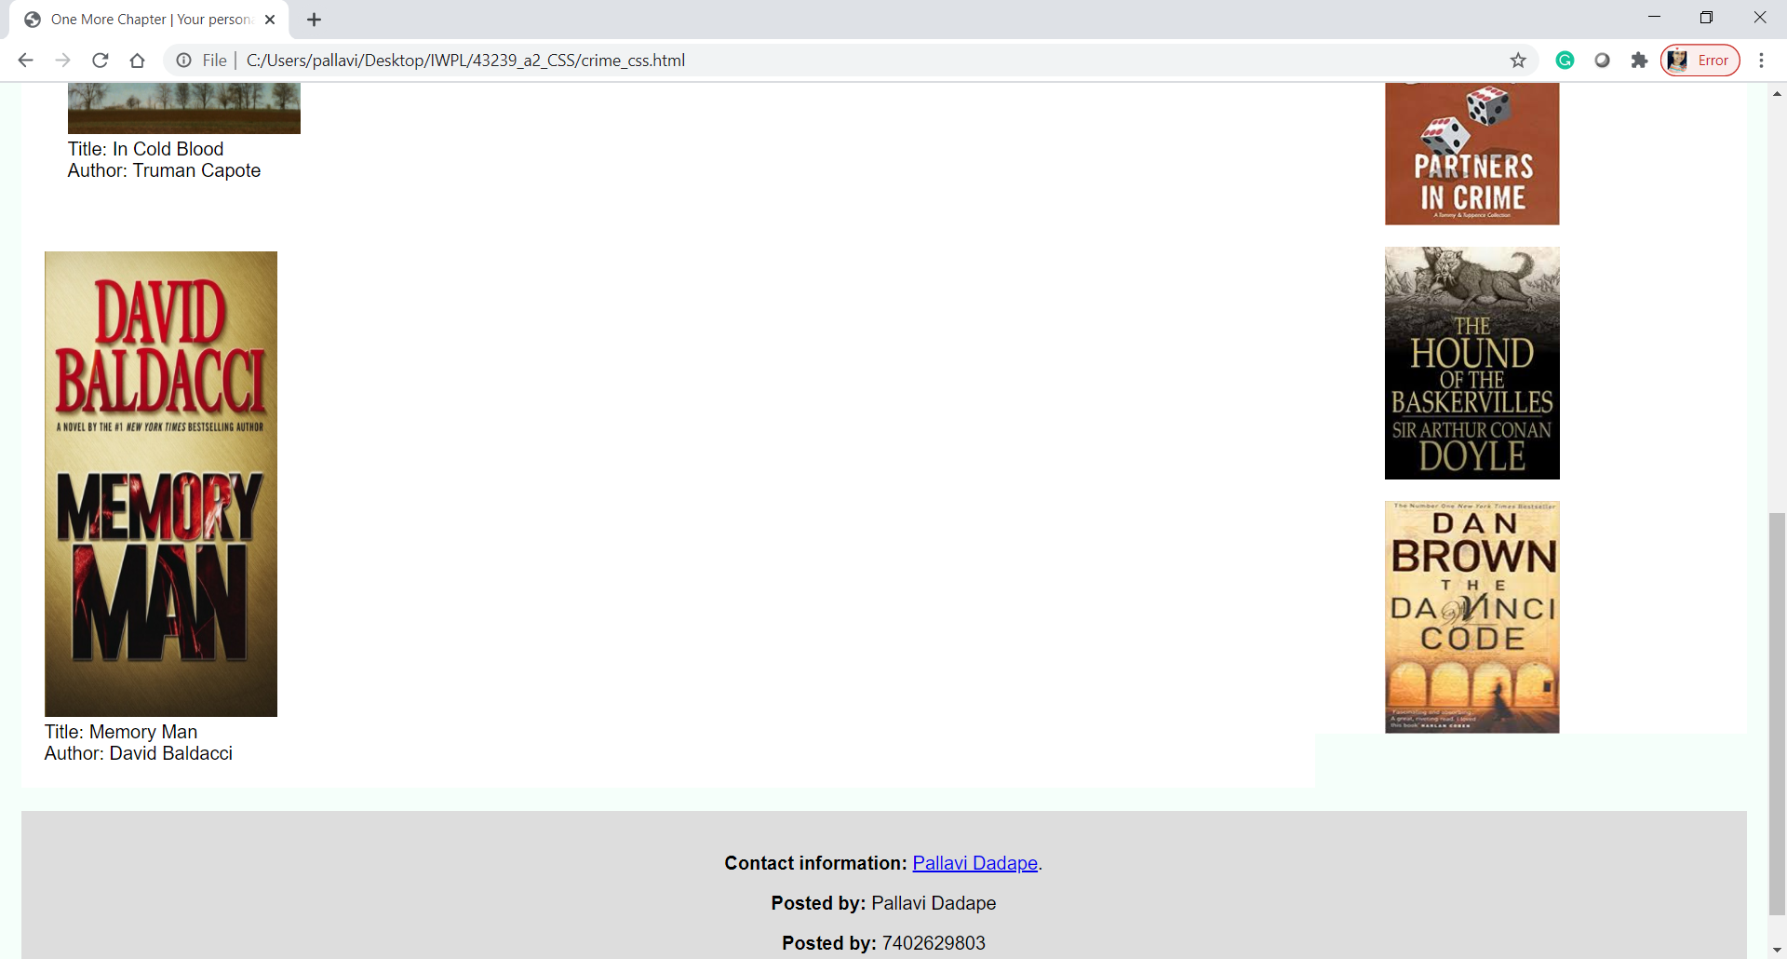

Screen 3.2 -

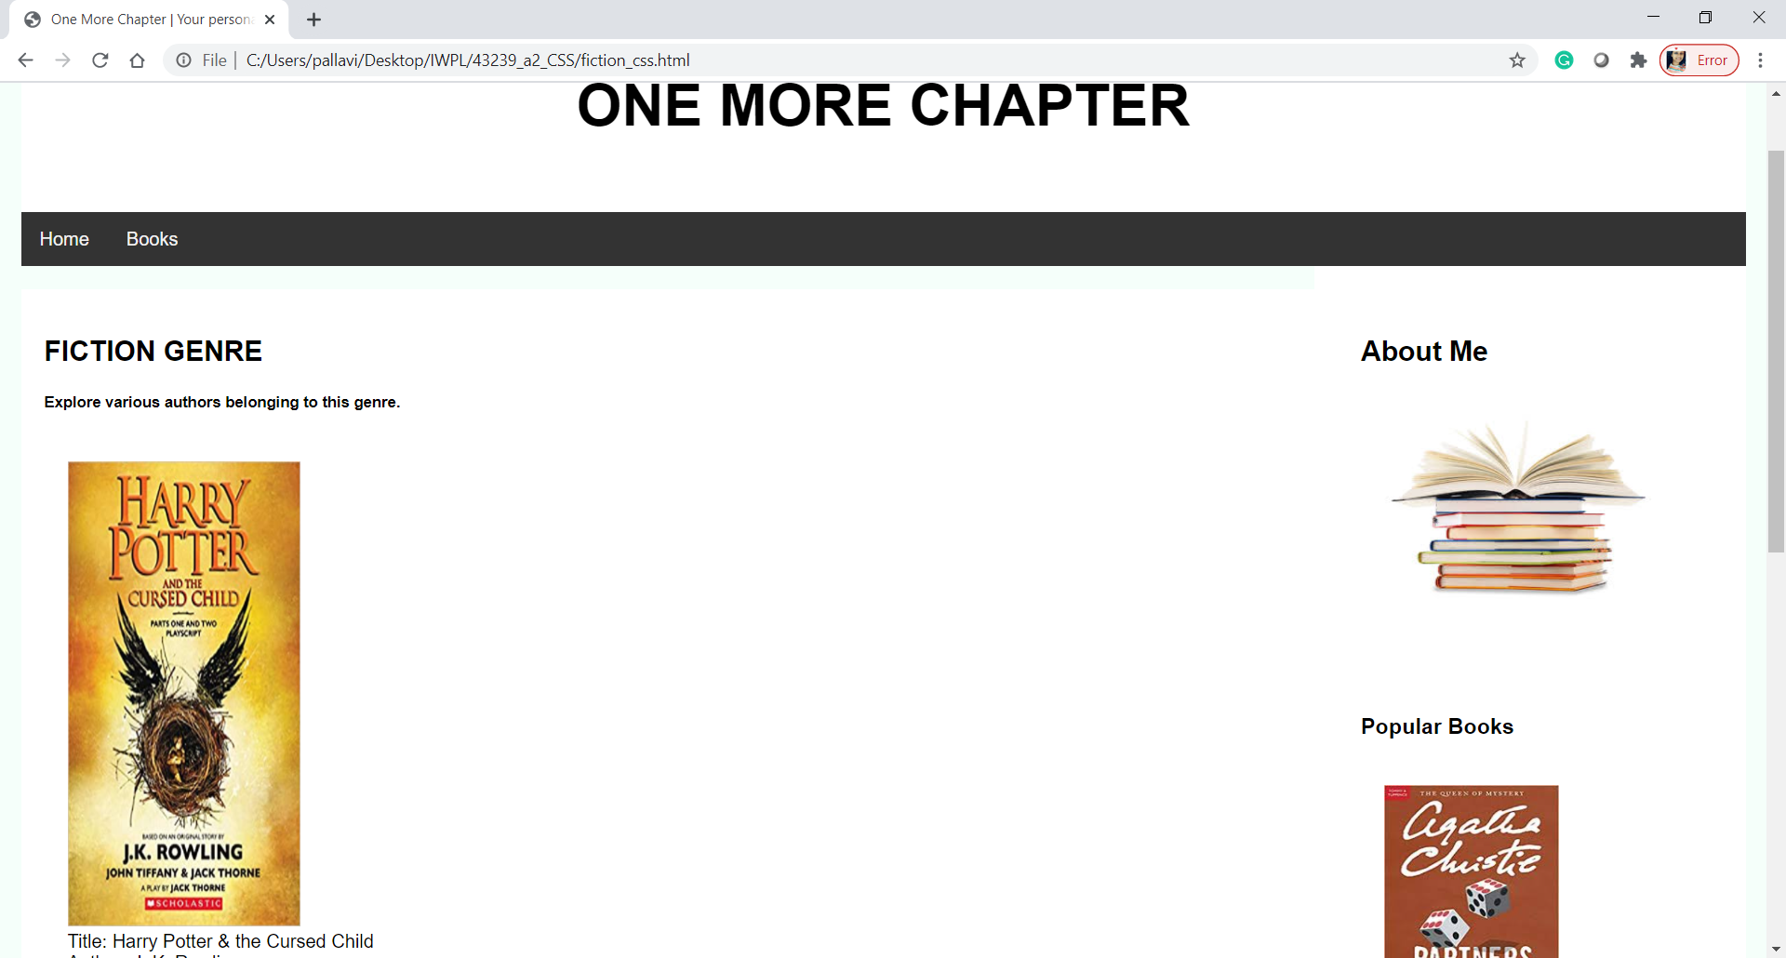

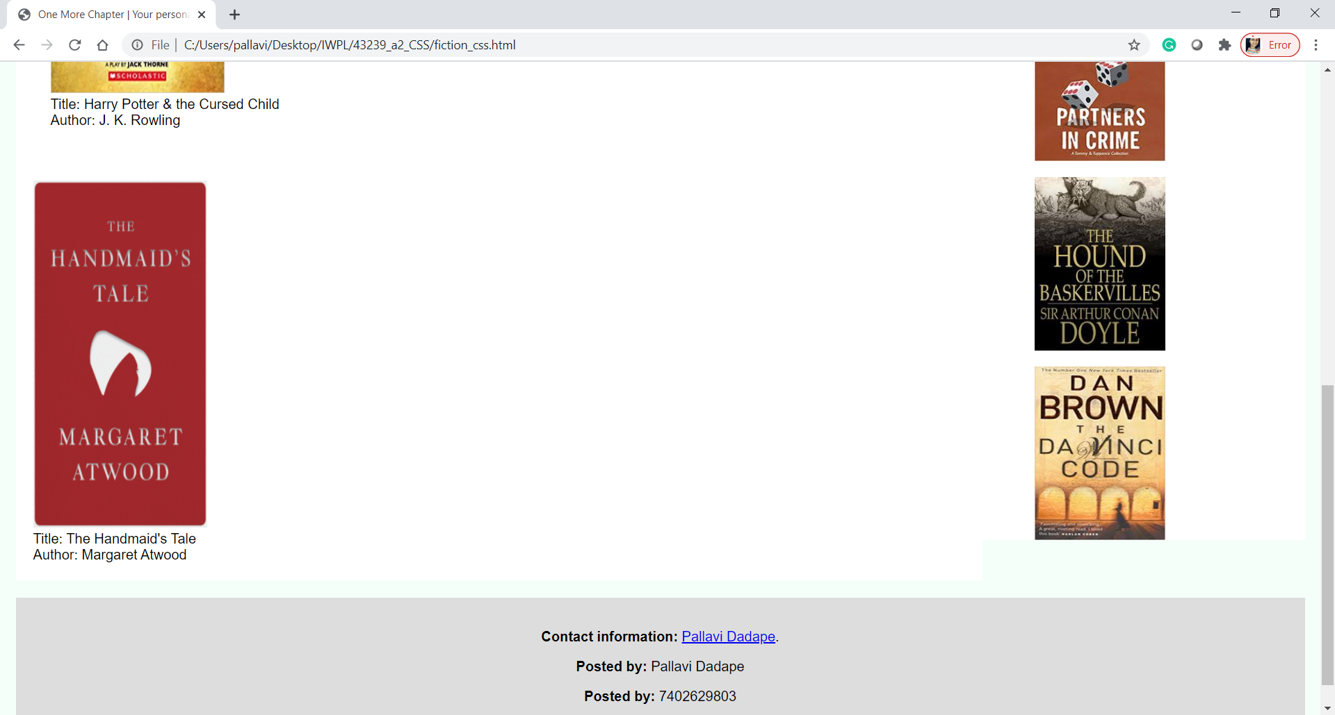

Screen 4 - After clicking on any book

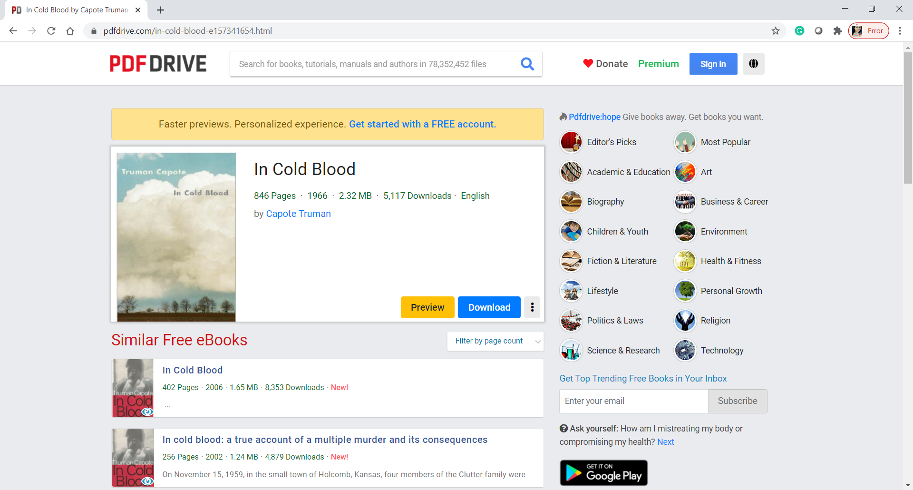

Conclusion

Thus, I have successfully implemented this assignment by using css to make an appealing book store website.